1. 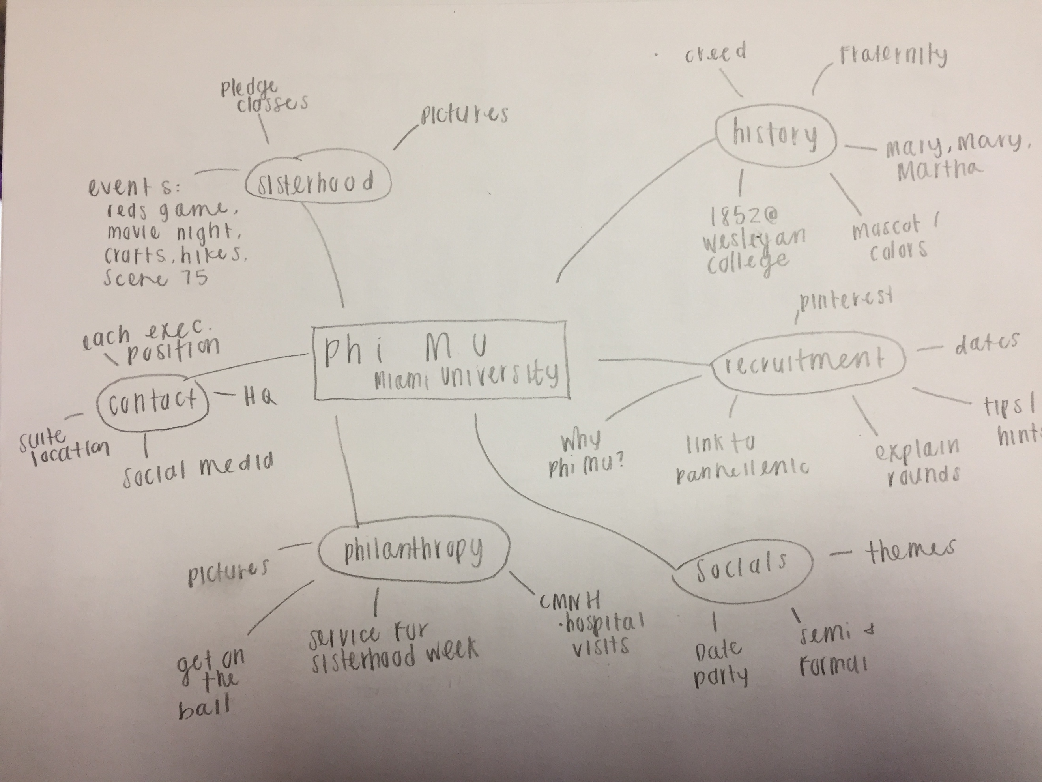Creative process

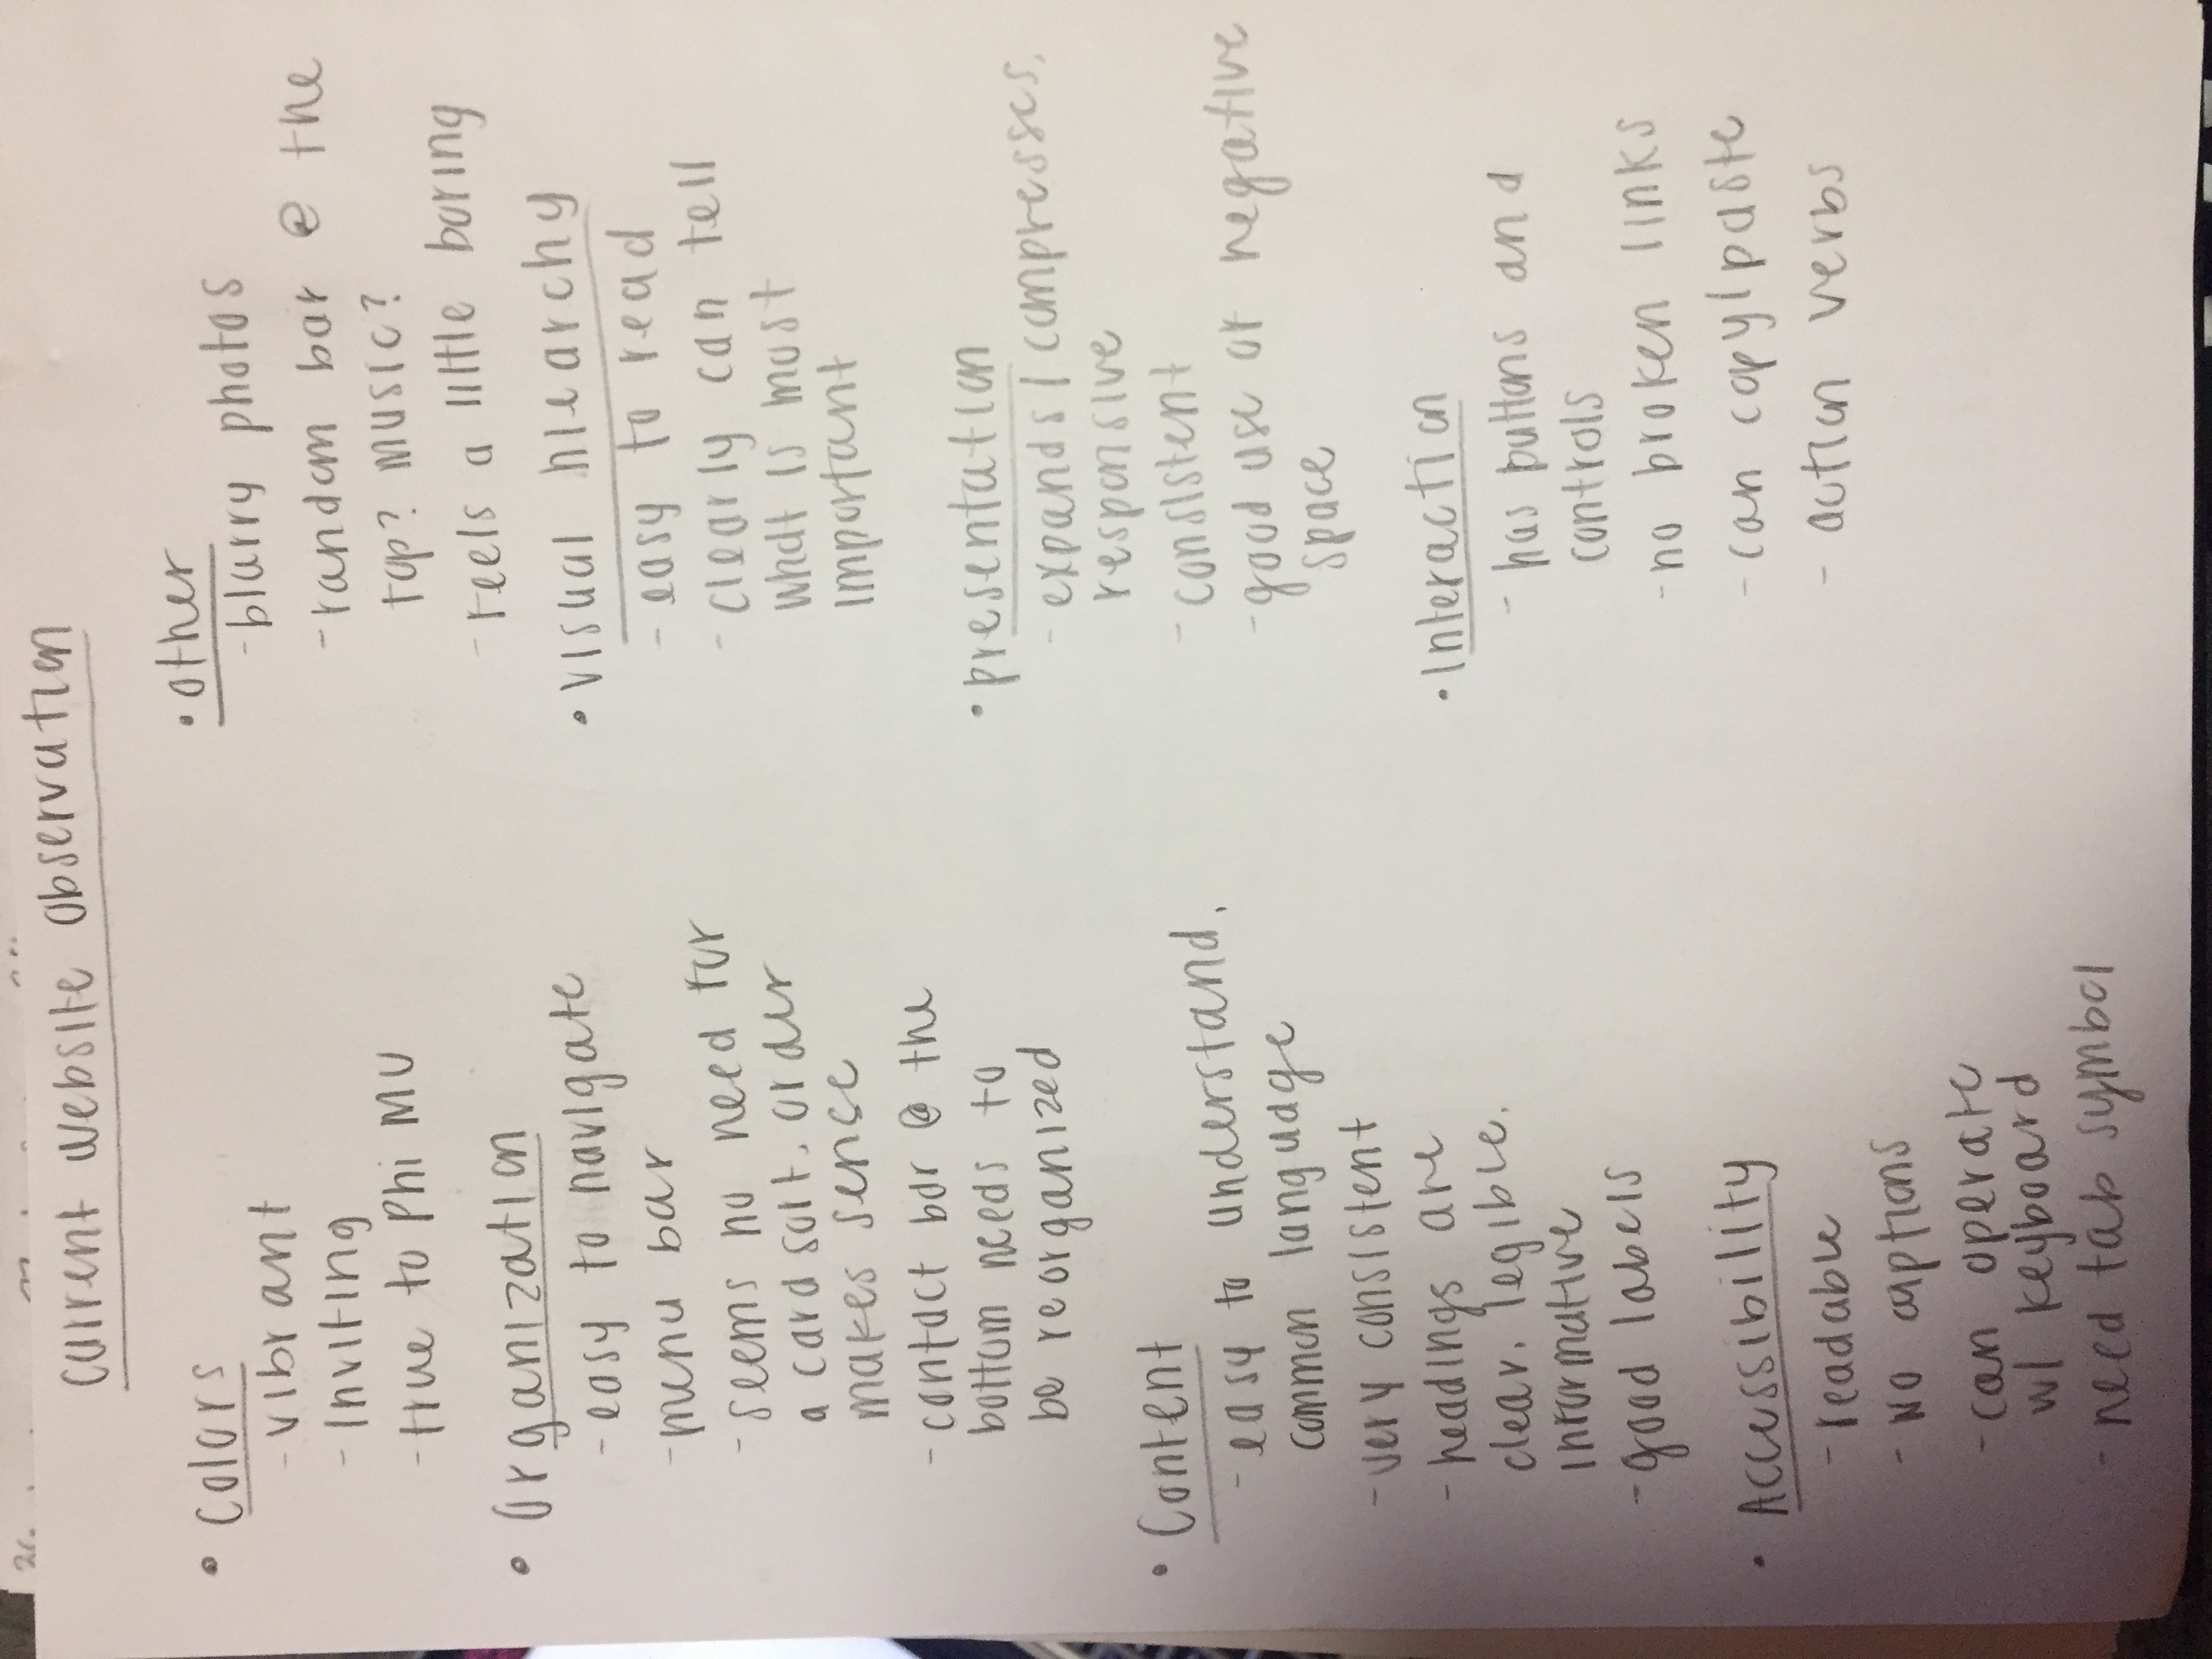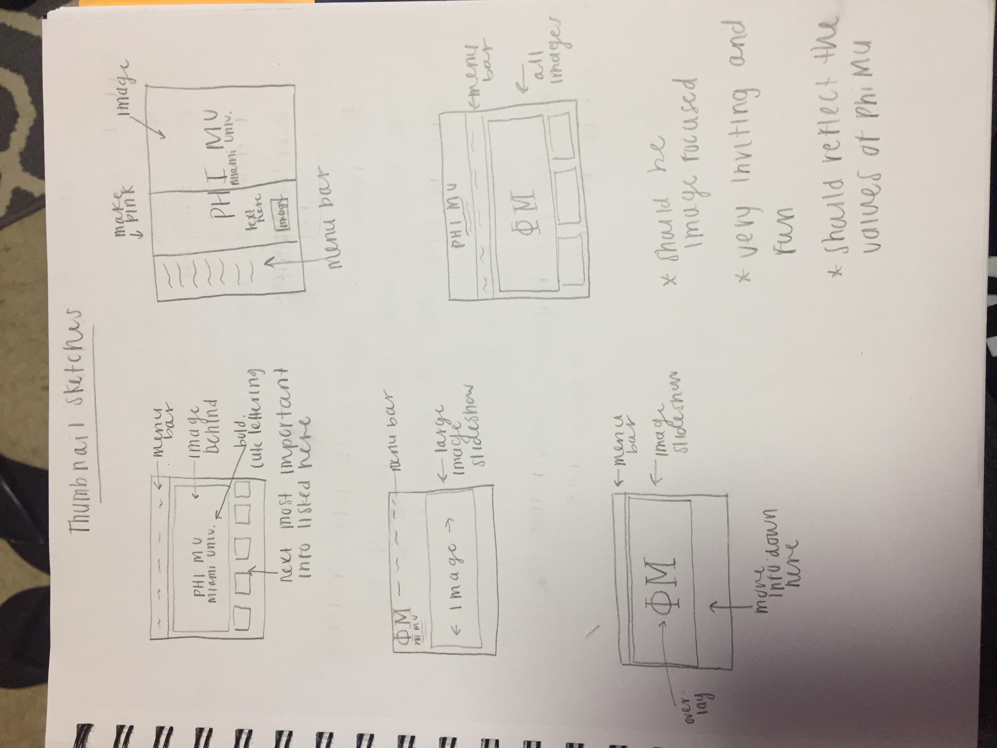

1. Research Methods

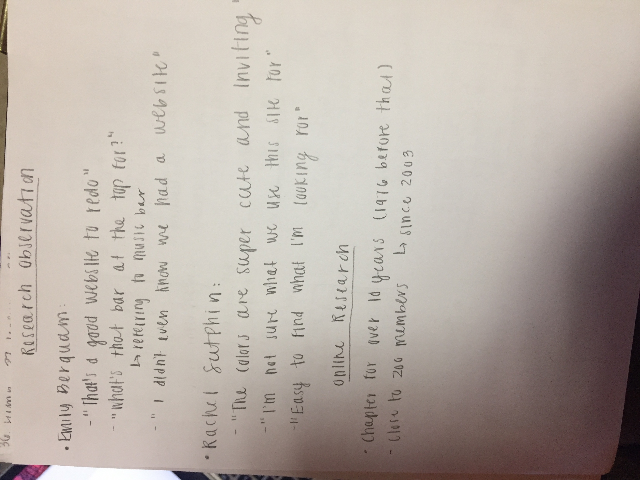

Emily Berquam

10/25/16

1. What is your relation to Phi Mu? Do you hold any positions?

I am an initiated member and do not currently hold any positions.

1. How long have you been a member?

I have been a member since spring of 2016.

1. Have you ever used the Phi Mu website before?

No I have not.

1. After seeing the site, what are you initial impressions?

There is not much content to it and I am not sure what the point of it is.

1. Do you feel that the site reflects the values of Phi Mu?

Yes, it has our colors and symbols. It also features pictures of the girls in Phi Mu.

1. What could you see yourself or others using the Phi Mu website for?

To keep up with what we are currently doing in the chapter (example: philanthropy events), good resource for alumni to keep in touch.

1. As a member, what are a few of the things you would like to see on the site?

I would like to see stuff about our philanthropy, like how much money we have raised. I would also like to see a spotlight on our sisters.

1. Is there any information that is vital to Phi Mu that you think is missing from the site?

I think in general is should look more up to date and have more information. It seems very barren. Specifically I think we need more content about our current sisters.

1. In my opinion, the most important use for the site will be to attract future members. What do you think the most important use will be for the site?

I think keeping alumni updated on the current happenings of our chapter is the most important aspect of the website.

1. Personas

IMS222/Persona%202%20copy.pdf

IMS222/Persona%201%20%20copy.pdf

1. Paper Prototype 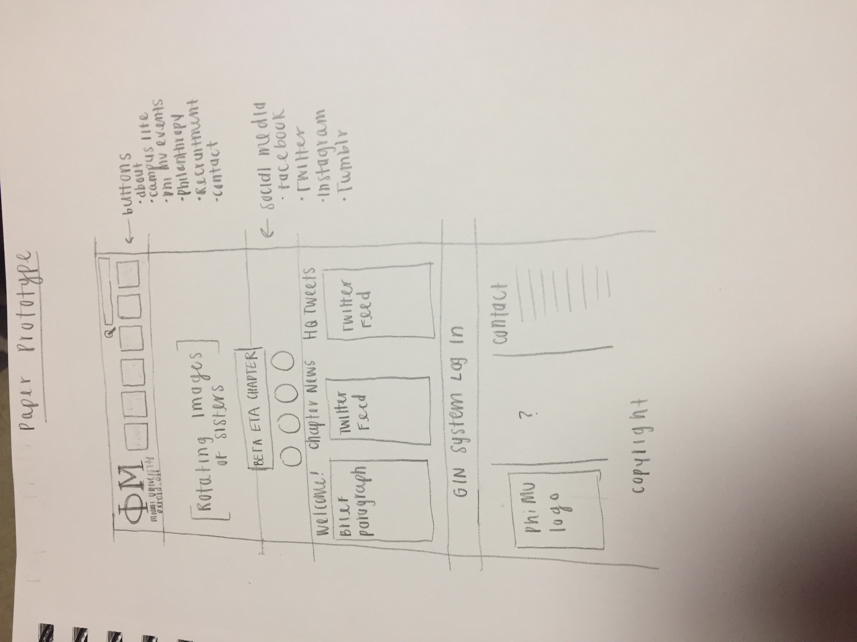
2. Content
3. Sisterhood
   * Include pictures
   * Pledge class rosters
   * Examples of past events
   * Any upcoming events
4. Contact
   * Bio about each executive member
   * Headquarters info
   * Social media
   * Suite location at Miami
5. Philanthropy
   * Include pictures
   * Get on the ball
   * Service for sisterhood week
   * Hospital visits
   * Link to CMHN website
6. History
   * Creed
   * Fraternity
   * Mary, Mary, Martha (M3 Foundation)
   * Mascot
   * Colors
   * 1852 @ Wesleyan College
7. Recruitment
   * Information about the process
   * Pinterest board
   * Important dates
   * Upcoming events
   * Tips/hints
   * Why go Phi Mu?
   * Link to Panhellenic
8. Socials

* Include pictures
* Date party
* Semi & formal
* Themes